KPSA 2024
62nd Annual Meeting of the
Kentucky Political Science Association

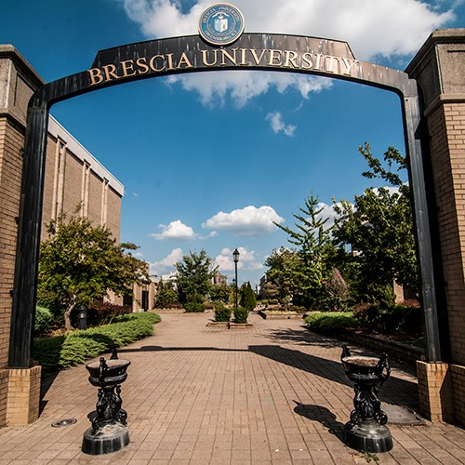
March 1st – 2nd, 2024
Hosted by Kentucky Wesleyan College and Brescia University
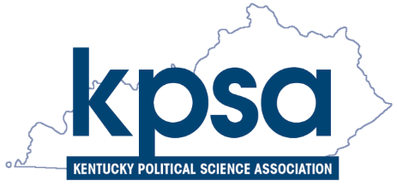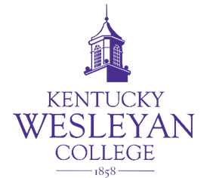
The 2024 KPSA Annual Conference has events at both Brescia University and Kentucky Wesleyan College. All Pannels and the CRPS Editorial board meeting will be held at Brescia, while the KPSA business meeting, reception, and dinner will be held at KWC.

Pannels will be held at Brescia University in the C.E. Field Center for Professional Studies, which is located at the southwestern corner of Brescia University’s campus, at the corners of Frederica Street and 9th Street in downtown Owensboro, Kentucky. There is an elevator available in the center of the building.

Convenient street parking is free and often available along Frederica Street with no time limit. People may also park freely in Brescia University parking lots without permits. A small parking lot is available at the C.E. Field Center. People can access it by turning onto 8th Street off of Frederica Street (see map). Brescia University’s address is: 717 Frederica Street, Owensboro, KY 42301

Friday’s reception and dinner will be held at Kentucky Wesleyan College, in Rogers Hall, inside the Winchester Center. Ample parking is available in the large lot adjacent (North; right of #3 on the map) to the Winchester Center (see map). Maps are also available on the next pages of this program. Kentucky Wesleyan College’s Address is: 3000 Frederica Street, Owensboro, KY 42301

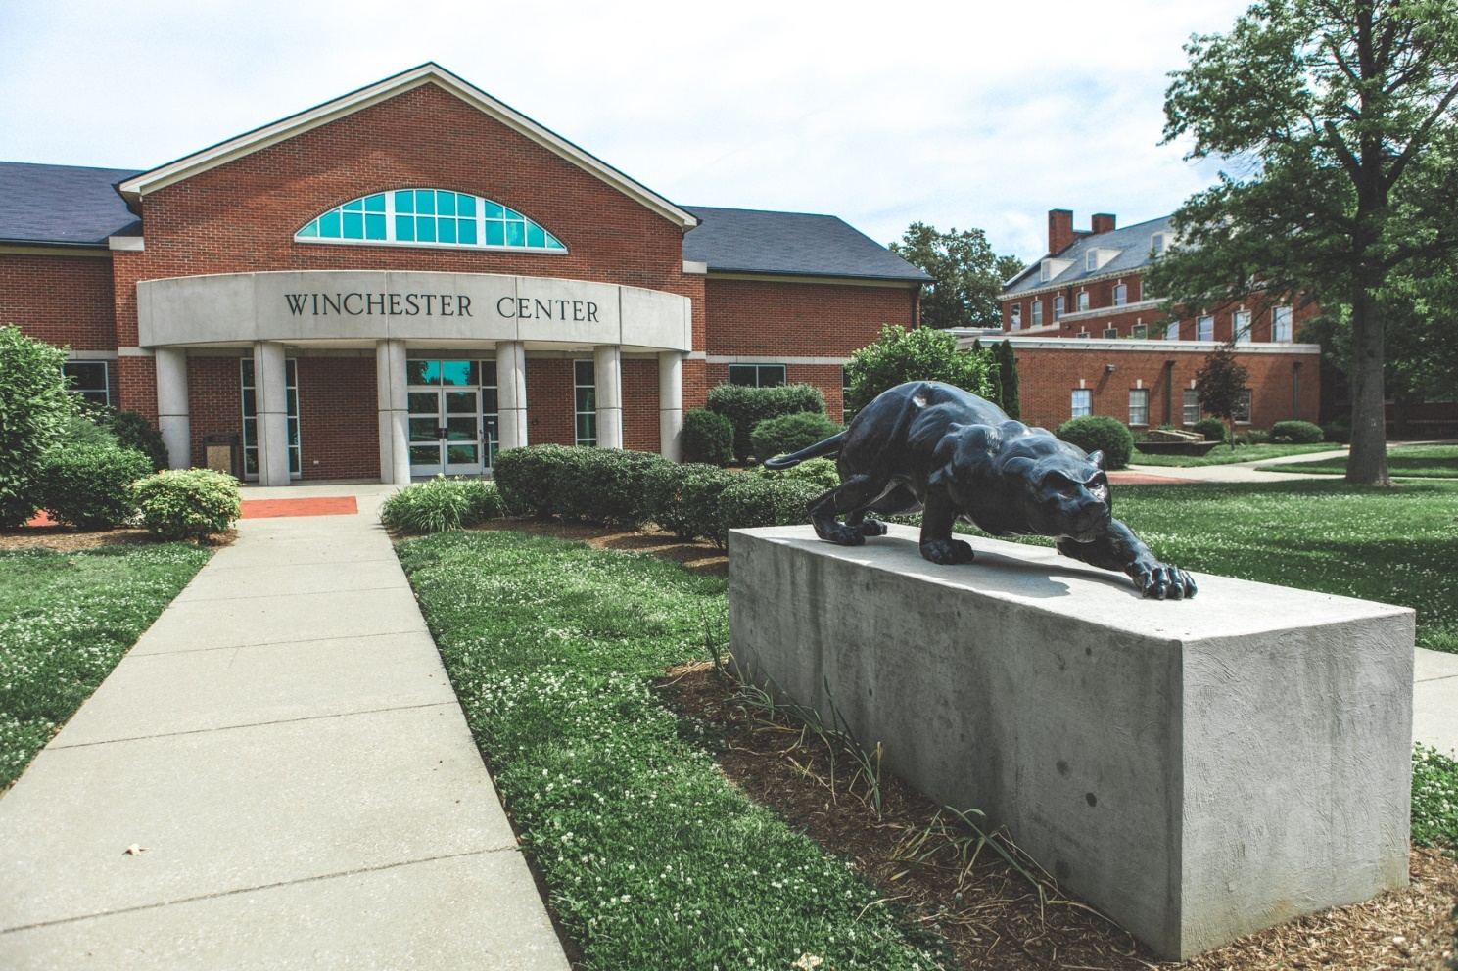
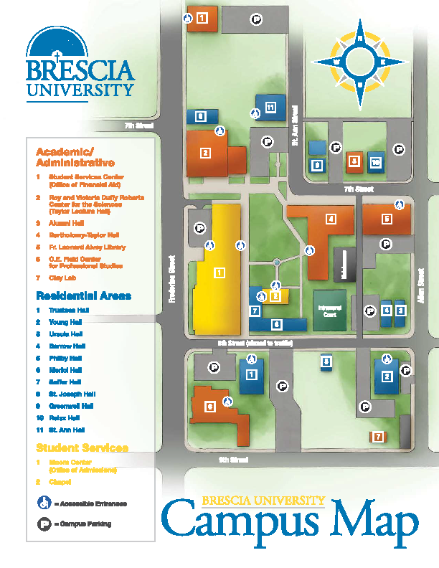

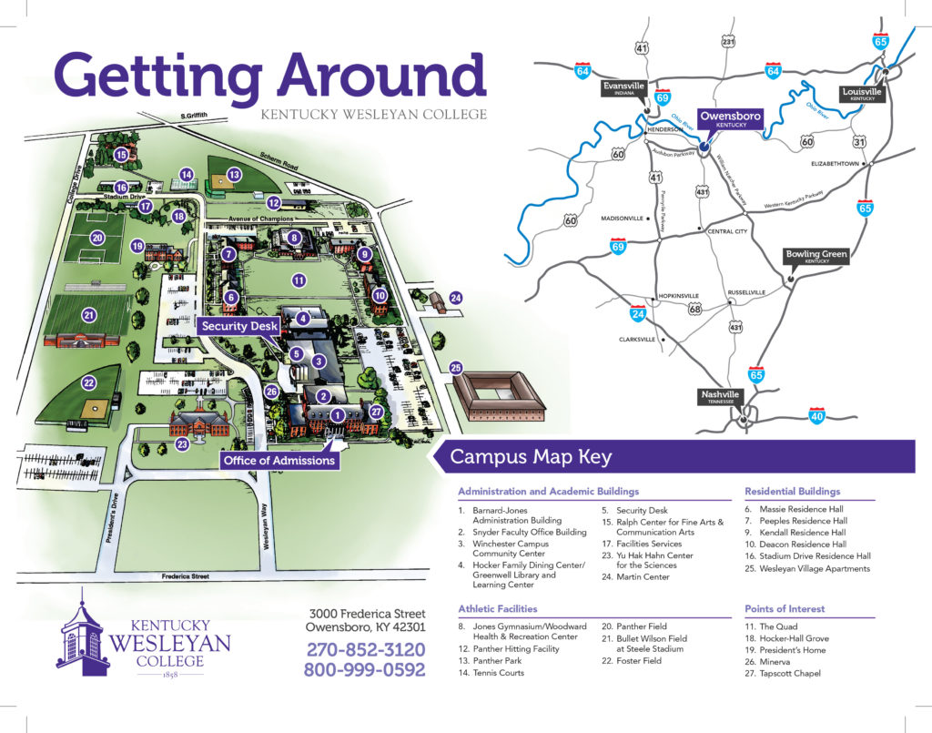

If you have any problems parking or finding the location, don’t hesitate to call or text:

(KWC) Dr. Eric Schmidt 269-599-9343 (cell)

(Brescia) Dr. Daniel Kuthy 757-348-8388 (cell)

Schedule

Friday, March 1st

Conference Registration (11:00 am to 5:00 pm)

Field Center, 215

Editorial Board Meeting (11:30 am to 12:30 pm)

Commonwealth Review of Political Science Editorial Board Meeting
Field Center, 212

Session 1 (12:45 pm – 2:00 pm)

Panel 1A – Field Center, 210

What Explains American Perceptions of Russia and China?

Shane Stryker (Undergraduate Student)
Western Kentucky University
shane.stryker614@topper.wku.edu

Sovereignty in the Real World

Ainsley Taylor (Undergraduate Student)
University of Louisville
ainsleyetaylor@icloud.com

State of Federalism in Pakistan: How Pakistan with Devolved Fiscal and Administrative Powers is Hybrid Democracy

Reagan Fournier (Undergraduate Student)
Western Kentucky University
reaganfbusiness@gmail.com

Risking Death to Find New Horizons: The Darien Gap and the Panamanian Response to the Crisis of Migration

Sophia Hermosilla (Undergraduate Student)
Thomas More University
Spencej@Thomasmore.edu

Chair/Discussant

Timothy S. Rich
Western Kentucky University
timothy.rich@wku.edu

Ihsan Alkhatib
Murray State University
ialkhatib@murraystate.edu

Panel 1B – Field Center, 211

The Modern Presidency and the Democratic Party: 1932-1968

Sean J. Savage
Saint Mary's College
ssavage@saintmarys.edu

An Exploration of Parental Migrant Status and Educational Attainment

Juan Tavera (Undergraduate Student)
Brescia University
juan.tavera@brescia.edu

Retrospective and Prospective Impacts on Vote Choice in the 2004 United States Presidential Election

Canaan Thacker (Undergraduate Student)
Morehead State University
m1241832@moreheadstate.edu

Chair/Discussant

Paul Foote
Murray State University
pfoote@murraystate.edu

Session 2 (2:15 pm – 3:30 pm)

Panel 2A – Field Center, 210

Advancing the Study of Politics and the Brain: Targets for Research on Neurology and Political Behavior

Glenn Rainey
Eastern Kentucky University
glenn.rainey@eku.edu

The Causes of Mass Casualty Civil Wars

Riley Vinson (Undergraduate Student)
Transylvania University
rcvinson25@transy.edu

The Fairytale of Democratic Theory: A Case Study of Latonia, Kentucky (1896-1909)

Andrew Bailey (Undergraduate Student)
Thomas More University
Spencej@Thomasmore.edu

Foreign Policy Analysis of the Causes of the War of 1812

Daniel Steitler (Undergraduate Student)
Brescia University
daniel.steitler@brescia.edu

Chair/Discussant

Eric Schmidt
Kentucky Wesleyan College
eric.schmidt@kwc.edu

Mason Horrell
Kentucky Wesleyan College
eric.schmidt@kwc.edu

Panel 2B – Field Center, 211

R-E-S-P-E-C-T: An Analysis of the Norm of Respectful Dissent in Post-Barrett Court

Alex Smith (Graduate Student)
University of Kentucky
alexander.smith@uky.edu

Dual Partisanship in America: Dead or Alive?

Livi Ray (Undergraduate Student)
Western Kentucky University
olivia.ray299@topper.wku.edu

Scott Lasley
Western Kentucky University
scott.lasley@wku.edu

Joel Turner
Western Kentucky University
joel.turner@wku.edu

Administrative Upheaval in the branches of the American Political Tree: The consequences of ending the Chevron Doctrine

Grady Ward (Undergraduate Student)
Murray State University
Gward5@murraystate.edu

Paul Foote
Murray State University
pfoote@murraystate.edu

Are Drug Courts Effective?

Audrey Stallings (Undergraduate Student)
Murray State University
audreystallings6@gmail.com

Chair/Discussant

Sean J. Savage
Saint Mary's College
ssavage@saintmarys.edu

John Heyrman
Berea College
heyrmanj@berea.edu

Panel 2C – Field Center, 213

Are You Satisfied?: An Analysis of Democratic Satisfaction amongst Self-Reported Identity Groups

Mallory Hardesty (Undergraduate Student)
Murray State University
lwyatt5@murraystate.edu

Hidden Outsiders on the Inside: Exploring the Impact of Trust in Government on Trump Voters in 2016 and 2020 Elections

Philip Hayden Terry III (Undergraduate Student)
Murray State University
pterry5@murraystate.edu

Republican Rhetoric and the Perception of Election Legitimacy

Caedmon Brewer (Undergraduate Student)
Berea College
brewerc@berea.edu

Rationales for Nonvoting in Louisville, Kentucky

Ethan Skolnick (High School Student)
duPont Manual High School
ejs0506ky@gmail.com

Chair/Discussant

Scott Lasley
Western Kentucky University
scott.lasley@wku.edu

Chris Kirkwood (Graduate Student)
University of Kentucky
cski230@uky.edu

Session 3 (3:45 pm – 5:00 pm)

Panel 3A – Field Center, 210

Taiwanese Belief that the US will aid in defense against a Chinese Invasion

Katrina Fjeld (Undergraduate Student)
Western Kentucky University
katrina.fjeld175@topper.wku.edu

Public Support in Taiwan for Extending Conscription and the Extent of That Support

Serena White (Undergraduate Student)
Western Kentucky University
serena.white621@topper.wku.edu

How Would a Runoff or Preference Voting System Have Changed Taiwan’s 2024 Presidential Election?

Timothy S. Rich
Western Kentucky University
timothy.rich@wku.edu

Chair/Discussant

Brittany Wood
Murray State University
bwood4@murraystate.edu

Panel 3B – Field Center, 211

The Siege Effect: Using Spatial Measures to Inform Group-Threat Research

D. Stephen Voss
University of Kentucky
dsvoss@uku.edu

Does Who Coaches Matter? Public Preferences of Coaching Characteristics for Female and Male Sports Teams

Eleri Gesler (Graduate Student)
Western Kentucky University
eleri.gesler@gmail.com

Scott Lasley
Western Kentucky University
scott.lasley@wku.edu

Kevin Elder (Graduate Student)
Western Kentucky University
ks_elder@outlook.com

LGBT Community or LGBT Subgroups: Linked Fate in LGBT People

Kay Hales (Graduate Student)
University of Kentucky
kayhales@uky.edu

Chair/Discussant

Wilfred Reilly
Kentucky State University
wilfred.reilly@kysu.edu

Friday Evening, March 1st

KPSA Networking Reception (5:15 pm to 6:30 pm)

Rogers Hall, Kentucky Wesleyan College

KPSA Business Meeting (5:15 pm to 6:15 pm)

Cox Conference Room, Kentucky Wesleyan College

KPSA Dinner (6:30 pm to 8:00 pm)

Rogers Hall, Kentucky Wesleyan College
Dinner and Awards
Speaker: Michael G. Adams, Kentucky Secretary of State

Saturday March 2nd

Registration, Donuts, & Coffee (8:00 am to 8:45)

Field Center, 215

Session 4 (8:45 am to 10:00 am)

Panel 4A – Field Center, 210

Unmanned Moral Forces: Drones & Information Warfare

Omer E. Ozkan (Graduate Student)
University of Cincinnati
ozkanoe@mai.uc.edu

Militias and Mayhem: Examining the Influence of Pro-Government Militias on the Onset of Civil Conflict

Ben Leo (Graduate Student)
University of Kentucky
bale230@uky.edu

Counterinsurgency Strategies and Foreign Military Assistance

John Gantner (Graduate Student)
University of Kentucky
johngantner@uky.edu

Chair/Discussant

James Taylor
Somerset Community College
james.taylor@kctcs.edu

Panel 4B – Field Center, 211

Modern Communication Technology and Women's Human Rights

Jingwen Wu (Graduate Student)
University of Kentucky
jwu246@uky.edu

Religion and the Gaza War

Ihsan Alkhatib
Murray State University
ialkhatib@murraystate.edu

From the West Bank to the South End: Gendered Displacement and State Violence

William (Ethan) Bleemel (Graduate Student)
University of Louisville
weblee01@louisville.edu

Coups and Women's Security

Jaclyn Johnson-Avalos
University of Kentucky
jaclyn.johnson@uky.edu

Bethany Abebe (Undergraduate Student)
University of Kentucky
bethany.abebe@uky.edu

Michaela Findley (Undergraduate Student)
University of Kentucky
michaela.findley@uky.edu

Mackenzie Everett (Undergraduate Student)
University of Kentucky
Mackenzie.everett@uky.edu

Chair/Discussant

Jane Rainey
Eastern Kentucky University
jane.rainey@eku.edu

Steven Jokinsky
University of Kentucky
steven.jokinsky@uky.edu

Panel 4C – Field Center, 213

"Predictors of Plague: a Quantitative Analysis of Determinants of National Success vs. COVID-19

Wilfred Reilly
Kentucky State University
wilfred.reilly@kysu.edu

Emmanuel Amadife
Kentucky State University
emmanuel.amadife@kysu.edu

Public Policies: Reasons why policies fail.

Shivam Sharma (Graduate Student)
Murray State University
ssharma4@murraystate.edu

Chair/Discussant

Glenn Rainey
Eastern Kentucky University
glenn.rainey@eku.edu

D. Stephen Voss
University of Kentucky
dsvoss@uku.edu

Session 5 (10:15 am to 11:30 am)

Panel 5A – Field Center, 210

Christianity, Confucianism, and Corruption: The Impact of Religion on LGBTQ+ Rights Policies in Japan, South Korea, and Taiwan

Matthew McCandless
Berea College
mccandlessm@berea.edu

“Ukraine has not yet perished”: National Anthems in the Fifteen Post-Soviet States as Devices for Creating New National Identities

Jane Rainey
Eastern Kentucky University
jane.rainey@eku.edu

Declining Party Membership? Linking European Party Membership and Deindustrialization

Steven Jokinsky
University of Kentucky
steven.jokinsky@uky.edu

Tyler Coleman,
High Point University
tcolema3@highpoint.edu

Chair/Discussant

Daniel Kuthy
Brescia University
daniel.kuthy@brescia.edu

Panel 5B – Field Center, 114—Duffy Auditorium

Election Presentation

Chris Kirkwood (Graduate Student)
University of Kentucky
cski230@uky.edu

Election Roundtable

D. Steven Voss
John Heyrman
Scott Lasley
Chris Kirkwood

Please join us at Murray State for the 2025 Annual Meeting of the Kentucky Political Science Association!

